1. A hydrocarbon is a gas at room temperature. When 1 mole of the compound burns in air, 2 mole of CO2 are produced. When it is bubbled into bromine water, the bromine loses colour. Which of the following compounds could it be?
2. C2H5OH b) CH2CHCH3
3. CH3CH3 d) CH2CH2
4. Asprin, whose structure is shown, contains which functional groups?

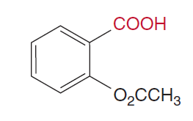

1. A ketone and an alcohol
2. An ester and a ketone
3. An ester and a carboxylic acid
4. A ketone, alcohol and ester
5. From the list of 4 compounds below, identify the compound that is NOT an isomer of any other compound in the list.

Butuanoic acid, butanal, methylpropanoate, ethylethanoate

1. Butuanoic acid
2. Butanal
3. Methylpropanoate
4. Ethylethanoate
5. Which of the following pure substances will have the highest melting point?
6. Ethane
7. Ethanal
8. Ethanoic acid
9. Ethanol
10. Which of the following compounds can have geometric isomers?

|  |  |
| --- | --- |
| 1. Image result | 1. Image result |
| 1. Image result | 1. Image result |

1. A student labelled an organic compound 1-bromo-2,2-dimethylethane, but the name was incorrect according to IUPAC standards. The correct name would be
2. 2-dimethyl – 1 – bromoethane
3. 1-bromo-2-methylpropane
4. 2-methyl-3-bromopropane
5. 1,1-dimethyl-2-bromoethane
6. Which of the following substances would you expect to be most soluble in water?
7. 1-butanol
8. Pentane
9. Propanone
10. Methylpropanal
11. Which of the following statements is FALSE?
12. Oxidation of 1-butanol with potassium permanganate produces butanal and subsequently butanoic acid
13. Oxidation of 2-butanol with potassium permanganate produces 2-butanone
14. Methane when treated with hydrogen chloride produces chloromethane and hydrogen gas
15. Ethanoic acid reacts with magnesium to produce hydrogen gas.

**Study the section of polymer below to answer questions 9 and 10:**

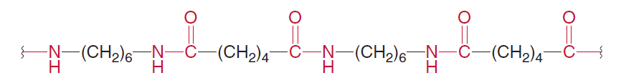

1. This segment is probably part of
2. A polyester
3. A polyamine
4. A polypeptide
5. A polycarbide
6. A monomer from the polymer could be:

NH2 – CH2 – CH2 - COOH

1. b)

c) d)

COOH – (CH2)6 – COOH

COOH – (CH2)5 – NH2

NH2 – (CH2)6 –NH2

END OF MULTIPLE CHOICE



**Year 12 Chemistry**

**Organic Chemistry Test 2016**

|  |
| --- |
| **Student Name: kk** |
| **Teacher: kk** |

* **60 minutes working time**
* **Non-programmable calculator and data sheet allowed.**

|  |  |  |  |  |
| --- | --- | --- | --- | --- |
| **Multiple Choice** | **Short Answer** | **Extended Answer** | **Total** |  |
|  |  |  |  |
| **10** | **23** | **27** | **60** |

**Section I – Multiple Choice**

Mark your choice with a cross (X). Please do not circle your answer.

|  |  |
| --- | --- |
| 1. **A B C ~~D~~** 2. **A B ~~C~~ D** 3. **A ~~B~~ C D** 4. **A B ~~C~~ D** 5. **A B C ~~D~~** 6. **A ~~B~~ C D** 7. **~~A~~ B C D** 8. **A B ~~C~~ D** 9. **A ~~B~~ C D** 10. **~~A~~ B C D** |  |

**Section II – Short Answer Questions**

**Question 1**

Identify the **organic** reactants that could be used to produce each of the following organic compounds (name or chemical formula):

|  |  |
| --- | --- |
| **Compound** | **Reactants** |
| Butanone | **Butan-2-ol (and permanganate / dichromate)** |
| 2-bromopropane | **Hydrogen bromide and propene** |
| Ethylheptanoate | **Ethanol and heptanoic acid** |

[3 marks]

**Question 2**

Give the correct IUPAC name or complete structural formula for the following compounds:

|  |  |
| --- | --- |
| IUPAC Name | Structural Formula |
| 2-amino-3-hydroxy-pentanoic acid | Image result for 2-amino-3-hydroxy-pentanoic acid |
| **3-bromo-4-fluorobutanal** | CH2 - CH – CH2 – CHO  | |  F Br |
| **3-ethyl-5-methylhex-1-ene** | CH2 = CH – CH – CH2 – CH3  |  CH2 – CH – CH3  |  CH3 |
| 2,4-dimethyl-cyclohexanol | Image result for 2,4-dimethyl-cyclohexanol |

[4 marks]

**Question 3**

Write balanced equations for the following reactions:

a) Combustion of octene in a plentiful supply of air.

 C8H16 + 12 O2 → 8 CO2 + 8 H2O

[2 marks]

b) The reaction between ethanoic acid and solid sodium carbonate.

2 CH3COOH + Na2CO3 → 2 CH3COO-Na+ + CO2 + H2O

[2 marks]

c) The reaction between potassium dichromate with ethanal.

CH3CHO + H2O → CH3COOH + 2 H+ + 2e- x3

Cr2O72- + 14 H+ + 6 e- → 2 Cr3+ + 7 H2O

3 CH3CHO + Cr2O72- + 8 H+ → 3 CH3COOH + 2 Cr3+ + 4 H2O

[3 marks]

**Question 4**

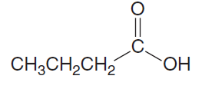The molecular formula C4H8O2 can represent the molecule shown below:

Butanoic acid:

There are many isomers of this molecule. Draw **two** that are esters and **one** that is a carboxylic acid.

|  |  |
| --- | --- |
|  | **Structure** |
| Ester | Ethyl ethanoate  Methyl propanoate  Propyl methanoate |
| Ester | Any two of the above |
| Carboxylic acid | Any carboxylic acid with 4 carbons |

[3 marks]

**Question 5**

1. What is a monomer?

**Small molecule that can be joined to others of the same kind to make a polymer**.

[1 mark]

1. 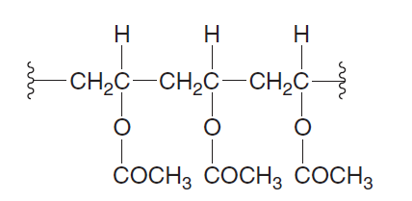Poly vinyl acetate is a soluble polymer with the following structure.
2. Draw the structure of the monomer responsible for the polymer.

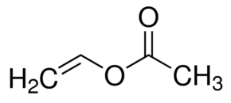

[2 marks]

1. The structural formulae for terephthalic acid and 1,3-propandiol are shown below:

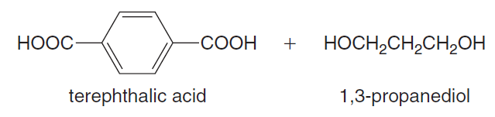

Using these monomers draw a section polymer showing exactly two complete repeating units.

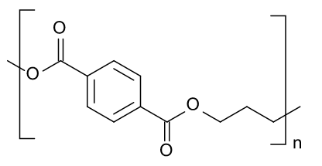

**Two units shown**

[2 marks]

1. State the type of polymerization involved in this reaction:

**Condensation**

[1 mark]

**Section III – Extended Answer Questions**

**Question 6**

Amino acids form polymers through peptide linkages.

1. Connect two **alanine** molecules with a peptide link.

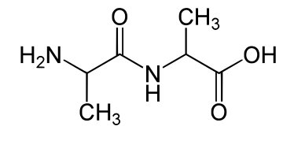

[2 marks]

1. Amino acids exist as zwitterions. Rewrite **alanine** as it would be found at the pH values indicated below:

|  |  |
| --- | --- |
| **pH** | **Structure of Alanine** |
| **3** |  |
| **7** |  |
| **10** |  |

[3 marks]

1. Circle and name the three amino acids that have been used to make the polypeptide shown below.

**alanine alanine serine**

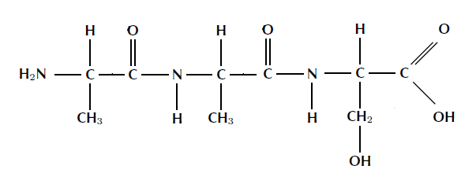

[3 marks]

1. Explain the following with regard to protein structure and explain how each structure is held together.

|  |  |
| --- | --- |
| Primary | **The primary structure of a protein is the sequence of amino acids in the polypeptide chain or chains.** |
| Secondary | **The repeated coiling and folding of a polypeptide chain due to hydrogen bonding between the amine hydrogen and acid oxygen atoms on the protein backbone.** |
| Tertiary | **3D structure of a protein due to interactions between amino acid side chains (R groups).** |

[3 marks]

1. Label the different parts of the diagrams below:

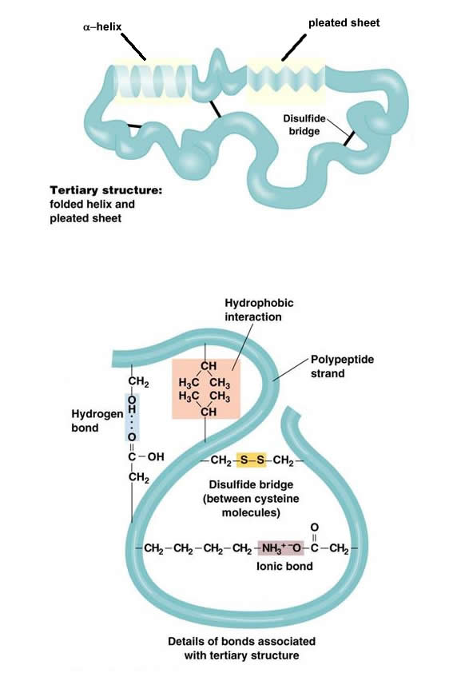

**Beta pleated sheet**

**Alpha helix**

**Secondary structure**

**Hydrophobic interactions**

**Hydrogen bonding**

**Disulfide bonds**

**Ionic bonding**

DETAILS OF BOND TYPES

[7 marks]

1. Explain how heat and pH changes can disrupt protein structure.

* **pH too high will convert -NH3+ to NH2, or too high will convert C-O- to -C-OH which will disrupt ionic bonds**
* **Higher kinetic energy can disrupt IM forces within protein**
* **Protein can ‘uncoil’ or lose shape**

[3 marks]

**Question 7**

A sample of a compound containing carbon, hydrogen and nitrogen only was burned in oxygen and produced 2.64 g of carbon dioxide, 0.630 g of water and 0.460 g of nitrogen dioxide.

1. ***n*(CO2) = = 0.05999 mol = *n*(C) in the compound ✓**

***n*(H2O) = = 0.03497 mol✓**

***n*(H) in the compound = 2 × 0.03497 = 0.06994 mol✓**

***n*(NO2) = = 0.009998 mol = *n*(N) in the compound✓**

|  |  |  |  |
| --- | --- | --- | --- |
|  | **C** | **H** | **N** |
| **Mole:** | **0.05999** | **0.06994** | **0.009998** |
| **Ratio:** |  |  | **✓** |
| **=** | **6** | **6.995** | **1** |
| **≈** | **6** | **7** | **1** |

**The empirical formula is therefore C6H7N. ✓**

1. **molecular mass = *n* × formula mass**

**95 = *n* × 93.126**

***n* ≈ 1**

**The molecular formula is therefore C6H7N. ✓**